Bahria University,

Karachi Campus



COURSE: CSC-113 COMPUTER PROGRAMMING

TERM: FALL 2019, CLASS: BSE- 1 (B)

Submitted By:

M MUAZ SHAHZAD 02-131202-081

(Name) (Reg. No.)

Submitted To:

Engr. Adnan ur rehman/ Engr. Ramsha Mashood

Signed Remarks: Score:

INDEX

|  |  |  |  |  |
| --- | --- | --- | --- | --- |
| SNO | DATE | LAB NO | LAB OBJECTIVE | SIGN |
| 01 | 2-jan-21 | 13 | Menu |  |
|  |  |  |  |  |
|  |  |  |  |  |
|  |  |  |  |  |
|  |  |  |  |  |
|  |  |  |  |  |
|  |  |  |  |  |
|  |  |  |  |  |
|  |  |  |  |  |
|  |  |  |  |  |
|  |  |  |  |  |
|  |  |  |  |  |
|  |  |  |  |  |
|  |  |  |  |  |
| SNO | DATE | LAB NO | LAB OBJECTIVE | SIGN |
|  |  |  |  |  |
|  |  |  |  |  |
|  |  |  |  |  |
|  |  |  |  |  |
|  |  |  |  |  |
|  |  |  |  |  |
|  |  |  |  |  |
|  |  |  |  |  |
|  |  |  |  |  |
|  |  |  |  |  |
|  |  |  |  |  |
|  |  |  |  |  |
|  |  |  |  |  |
|  |  |  |  |  |
|  |  |  |  |  |

Bahria University,

Karachi Campus



LAB EXPERIMENT NO.

13

LIST OF TASKS

|  |  |
| --- | --- |
| TASK NO | OBJECTIVE |
| 01 | Create a simple calculator using menu driven approach. |
| 02 | Create a simple application which will add employee, delete employee and search employee in array of profile |
|  |  |
|  |  |
|  |  |
|  |  |
|  |  |
|  |  |
|  |  |
|  |  |
|  |  |
|  |  |
|  |  |
|  |  |
|  |  |

Submitted On:

06/01/2021

(Date: DD/MM/YY)

**Task No. 1: Create a simple calculator using menu driven approach**

**Solution:**class Program

{

static void Addition(int a, int b)

{

Console.WriteLine("\n\t\t=======================");

Console.WriteLine("\t\tSum Of Two Numbers : " + (a + b));

Console.WriteLine("\n\t\tGo To Main Menu");

Console.WriteLine("\t\t=======================");

Console.ReadKey();

}

static void Substraction(int a, int b)

{

Console.WriteLine("\n\t\t=======================");

Console.WriteLine("\t\tSub Of Two Numbers : " + (a - b));

Console.WriteLine("\n\t\tGo To Main Menu");

Console.WriteLine("\t\t=======================");

Console.ReadKey();

}

static void Multiplication(int a, int b)

{

Console.WriteLine("\n\t\t=======================");

Console.WriteLine("\t\tMul Of Two Numbers : " + (a * b));

Console.WriteLine("\n\t\tGo To Main Menu");

Console.WriteLine("\t\t=======================");

Console.ReadKey();

}

static void Division(int a, int b)

{

Console.WriteLine("\n\t\t=======================");

Console.WriteLine("\t\tDiv Of Two Numbers : " + (a / b));

Console.WriteLine("\n\t\tGo To Main Menu");

Console.WriteLine("\t\t=======================");

Console.ReadKey();

}

static bool callmenu()

{

Console.Clear();

Console.WriteLine("\n\t\t\t================");

Console.WriteLine("\t\t\tM MUAZ SHAHZAD ");

Console.WriteLine("\t\t\t02-131202-081 ");

Console.WriteLine("\t\t\tBSE 1-B ");

Console.WriteLine("\t\t\tLAB 13 Task 1 ");

Console.WriteLine("\t\t\t================");

Console.WriteLine("\n\t\t==============================");

Console.WriteLine("\t\tPress 1 For Addition");

Console.WriteLine("\t\tPress 2 For Subtraction");

Console.WriteLine("\t\tPress 3 For Multiplication");

Console.WriteLine("\t\tPress 4 For Division");

Console.WriteLine("\t\tPress 5 To Exit");

Console.WriteLine("\t\t==============================");

Console.WriteLine("\n\t\t==================");

Console.WriteLine("\t\tChoose An Option ");

Console.WriteLine("\t\t==================");

switch (Console.ReadLine())

{

case "1":

{

int a, b;

Console.Write("\t\tEnter Number 1 : ");

a = Convert.ToInt32(Console.ReadLine());

Console.Write("\t\tEnter Number 2 : ");

b = Convert.ToInt32(Console.ReadLine());

Addition(a, b);

return true;

}

case "2":

{

int a, b;

Console.Write("\t\tEnter Number 1 : ");

a = Convert.ToInt32(Console.ReadLine());

Console.Write("\t\tEnter Number 2 : ");

b = Convert.ToInt32(Console.ReadLine());

Substraction(a, b);

return true;

}

case "3":

{

int a, b;

Console.Write("\t\tEnter Number 1 : ");

a = Convert.ToInt32(Console.ReadLine());

Console.Write("\t\tEnter Number 2 : ");

b = Convert.ToInt32(Console.ReadLine());

Multiplication(a, b);

return true;

}

case "4":

{

int a, b;

Console.Write("\t\tEnter Number 1 : ");

a = Convert.ToInt32(Console.ReadLine());

Console.Write("\t\tEnter Number 2 : ");

b = Convert.ToInt32(Console.ReadLine());

Division(a, b);

return true;

}

case "5":

{

return false;

}

default:

{

return true;

}

}

}

static void Main(string[] args)

{

bool menu = true;

while (menu)

{

menu = callmenu();

}

}

}

}

**Output: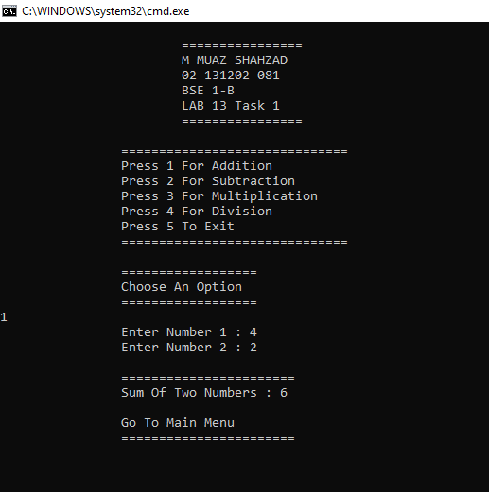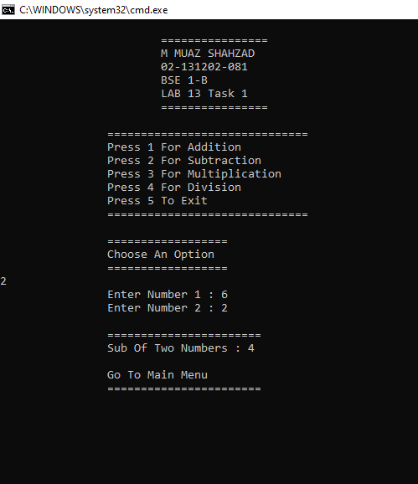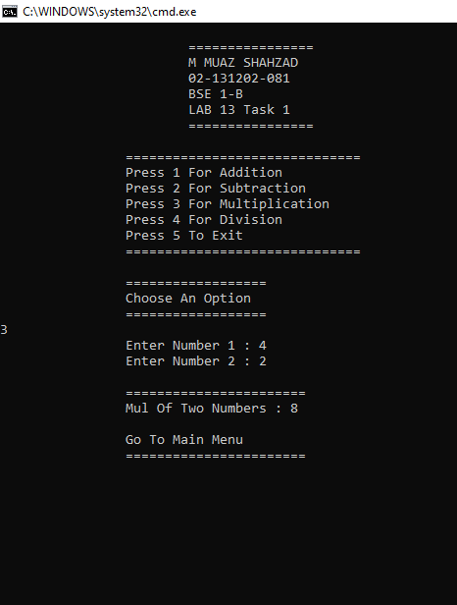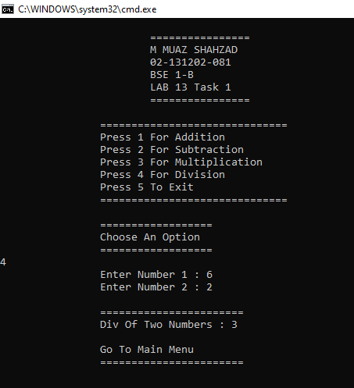 Task No. 2: Create a simple application which will add employee, delete employee and search employee in array of profile**

**Solution:**

class Program

{

static void addition(string[,] array)

{

Console.Write("\t\tEnter Name: ");

array[4, 0] = Console.ReadLine();

Console.Write("\t\tEnter ID: ");

array[4, 1] = Console.ReadLine();

Console.Write("\t\tEnter Gender: ");

array[4, 2] = Console.ReadLine();

Console.WriteLine("\t\tEmployee Info Added");

foreach (string a in array)

{

Console.WriteLine(a);

}

Console.ReadLine();

}

static void search(string[,] array)

{

Console.Write("\n\t\tFor Searching (0-3): ");

int a = Convert.ToInt32(Console.ReadLine());

for (int j = 0; j < 3; j++)

{

Console.WriteLine(array[a, j]);

}

Console.ReadLine();

}

static void delete(string[,] array)

{

Console.Write("\n\t\tEnter Serial Number To Delete (0-3): ");

int a = Convert.ToInt32(Console.ReadLine());

for (int i = 0; i < 3; i++)

{

array[a, i] = " \n\t\tNo Record ";

}

foreach (string z in array)

{

Console.WriteLine(z);

}

Console.ReadKey();

}

static bool menu(string[,] array)

{

Console.Clear();

Console.WriteLine("\n\t\t======================");

Console.WriteLine("\t\tChoose an Option:");

Console.WriteLine("\t\tPress 1 for Delete Employee");

Console.WriteLine("\t\tPress 2 for Search Employee ");

Console.WriteLine("\t\tPress 3 for Add an Employee ");

Console.WriteLine("\t\tPress 4 for Exit");

Console.WriteLine("\n\t\t======================");

Console.Write("\n\t\tChoose An Option: ");

int c = Convert.ToInt32(Console.ReadLine());

if (c == 1)

{

delete(array);

return true;

}

if (c == 2)

{

search(array);

return true;

}

if (c == 3)

{

addition(array);

return true;

}

else

{

return false;

}

}

static void Main(string[] args)

{

string[,] array = new string[5, 3]

{ { "\t\tWaleed", "\t\t001 ", "\t\tMale" },

{ " \n\t\tTalha ", "\t\t002", "\t\tMale" },

{ " \n\t\tUswa ", "\t\t003 ", "\t\tFemale " },

{ " \n\t\tFaiza", "\t\t004", "\t\tFemale" },

{ " ", "\t\t ", "\t\t " } };

bool final = true;

while (final)

{

final = menu(array);

}

Console.ReadLine();

}

}

}

**Output:**